**Table of Contents**

Lab 1: Tips for making Android Studio faster 2

Common Solution: 2

Individual Student’s Work: 2

Waleed Afandi: 2

Shamir Afridi: 2

Ahsan Usman: 3

Lab 2: Hello World Activities 4

Individual Student’s Work: 4

Waleed Afandi: 4

Tabbed Activity: 4

Basic Activity: 5

Bottom Navigation Activity: 6

Full Screen Activity: 7

Scrolling Activity 8



**Members:**

Waleed Afandi FA17-BCS-124

Shamir Afridi FA17-BCS-021

M.Ahsan Usman FA17-BCS-037



# Lab 1: Tips for making Android Studio faster

# Common Solution:

# Individual Student’s Work:

# Waleed Afandi:

1. Change Build process heap size (Mbytes) to 1024 and Additional build process to VM Options to -Xmx512m.
2. Only open the project you are currently working on

## Shamir Afridi:

**Problem: Install SSD in your system and make sure android studio is installed onto the SSD.**

If you do not have SSD in your system, these are some tips which would increase your performance of android studio even on HDD.

1. **Keep the tools up-to-date**

The Android tools receive build optimizations and new features with almost every updates. To take advantage of the latest optimizations, keep the following up to date:

* [Android Studio and SDK tools](https://developer.android.com/studio/intro/update)
* [The Android plugin for Gradle](https://developer.android.com/studio/releases/gradle-plugin)

1. **Create a build variant for development**

Many of the configurations you need when [preparing your app for release](https://developer.android.com/studio/publish/preparing) are not required while developing your app. Enabling unnecessary build processes slows down your incremental and clean builds

1. **Enable single-variant project sync**

[Syncing your project](https://developer.android.com/studio/build#sync-files) with your build configuration is an important step in letting Android Studio understand how your project is structured. You need to use Android Studio 3.3 or higher with Android Gradle Plugin 3.3.0 or higher to enable this optimization.

1. **Avoid compiling unnecessary resources**

Avoid compiling and packaging resources that you aren't testing (such as additional language localizations and screen-density resources). You can do that by only specifying one language resource and screen density for your "dev" flavor,

1. **Disable Crashlytics for your debug builds**

If you don't need to run a [Crashlytics report](https://docs.fabric.io/android/crashlytics/overview.html), speed up your debug builds by disabling the plugin

1. **Enable offline mode**

If you are on a slow network connection, your build times may suffer when Gradle attempts to use network resources to resolve dependencies.

1. **Use static dependency versions**

When you declare dependencies in your build.gradle files, you should avoid using version numbers with a plus sign at the end, such as 'com.android.tools.build:gradle:2.+'.

1. **Convert images to WebP**

[WebP](https://developers.google.com/speed/webp/) is an image file format that provides lossy compression (like JPEG) as well as transparency (like PNG) but can provide better compression than either JPEG or PNG. Reducing image file sizes, without having to perform build-time compression, can speed up your builds, especially if your app uses a lot of image resources.

1. **Reference**: https://developer.android.com/studio/build/optimize-your-build

# Ahsan Usman:

1. Restart your windows before working on android studios. This way all the unwanted background tasks will be closed and there will be more memory available for Android Studios.

# Lab 2: Hello World Activities

# Individual Student’s Work:

# Waleed Afandi:

### Tabbed Activity:

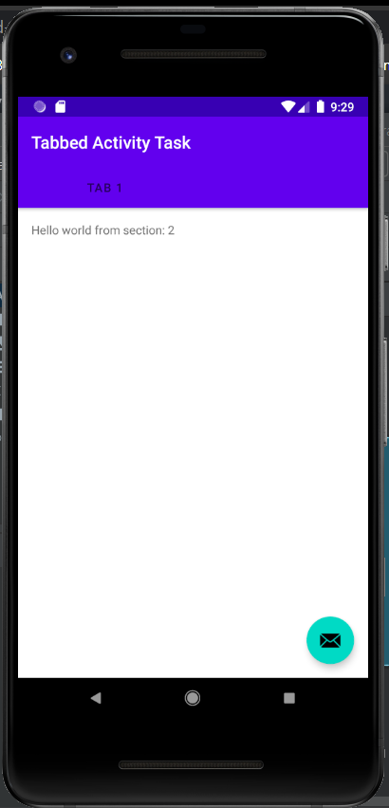

### Basic Activity:

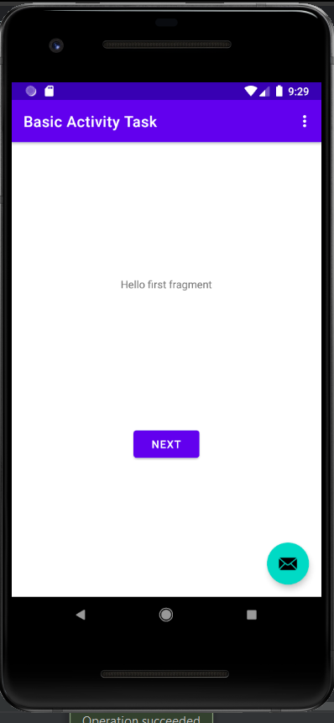

### Bottom Navigation Activity:

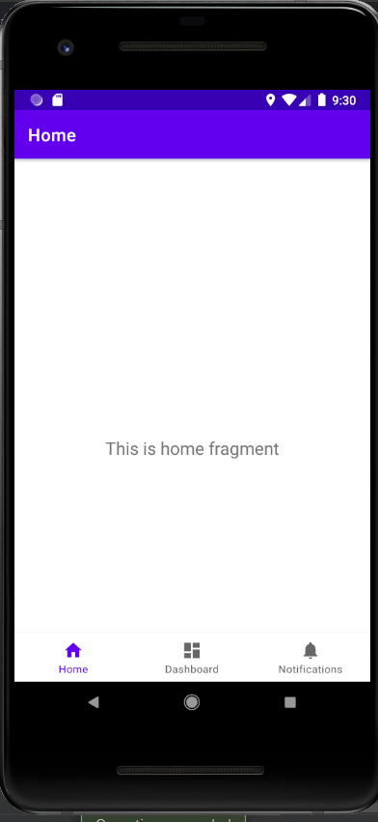

### Full Screen Activity:

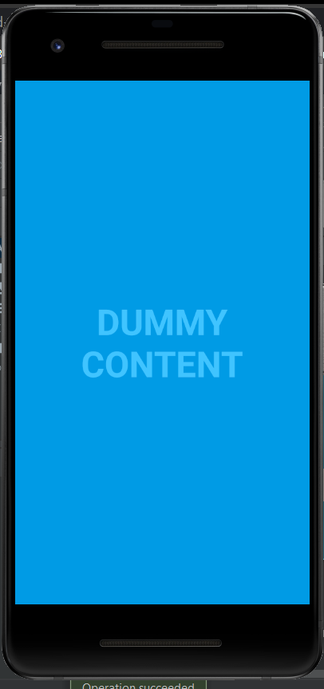

### Scrolling Activity

